2019 Birchwood Road Race map and cue sheet.
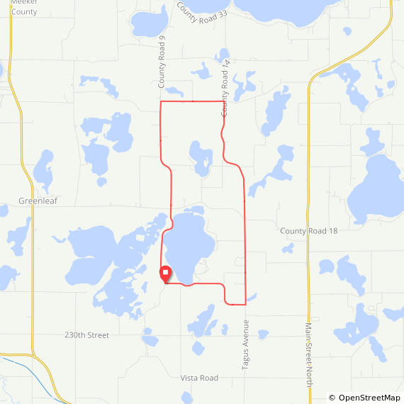

Cue Sheet
Continue onto CSAH 9 | 0.8 mi
Turn right onto 195th St | 4.6 mi
Turn right onto CSAH 14 | 6.1 mi
Continue onto Tagus Ave | 9.9 mi
Turn right onto Belle Lake Rd | 11.2 mi
Turn right onto Vista Rd | 13.5 mi

